PROJECT REPORT : HEALTHCARE SECURITY

Medical Strongroom
A role-based clinic records application with layered sign-in protection
Medical Strongroom is an educational Flask application designed to demonstrate how a small clinic can separate staff responsibilities, restrict access to patient records, protect clinical notes, and record important actions. The project combines account approval, password verification, an encrypted key file stored on a regular USB drive, patient assignment checks, note encryption, and an integrity-checked audit log.

1. Problem and project objectives
Healthcare records need careful handling because different staff members need different information to perform their jobs. A front-desk worker may need patient contact details to organize care, while a clinician needs access to clinical notes only for patients assigned to that clinician. The project models these boundaries in a single local web application.
The project objectives are to:
- Separate responsibilities for administration, front-desk work, patient assignment, and clinical care.
- Require administrator approval for public staff registration requests.
- Protect sign-in with bcrypt password hashes and a second factor based on a cryptographic challenge.
- Limit clinicians to patients assigned to them and prevent front-desk accounts from opening clinical notes.
- Encrypt clinical notes and detect changes to audit records.
- Demonstrate security controls through focused automated regression tests.

2. Users and workflow
The application uses role checks in its routes and patient-assignment checks in its data-access functions. The dashboard presents actions that match the signed-in user’s role.
Role | Main responsibilities
Administrator | Uses a predetermined, bootstrapped account to approve or reject staff requests, manage staff accounts, reset staff passwords, and review audit metadata. The administrator does not receive patient-record access through the admin role.
Front desk | The predetermined Paris Anderson account can be bootstrapped for the demonstration. Front-desk staff create and update patient demographics and scheduling information, but cannot open clinical-note routes.
Assignment lead | A clinician account with an additional permission to assign patients. The lead can assign a patient to another clinician or to themself.
Clinician | Views only patients assigned to their account and can create, view, and edit notes for those patients.

Public staff registration creates a pending request. The administrator must approve it before the staff member can sign in. On first sign-in, the staff member enrolls a key file. Later sign-ins require both the account password and a valid signature from the enrolled key.
For the administrator:
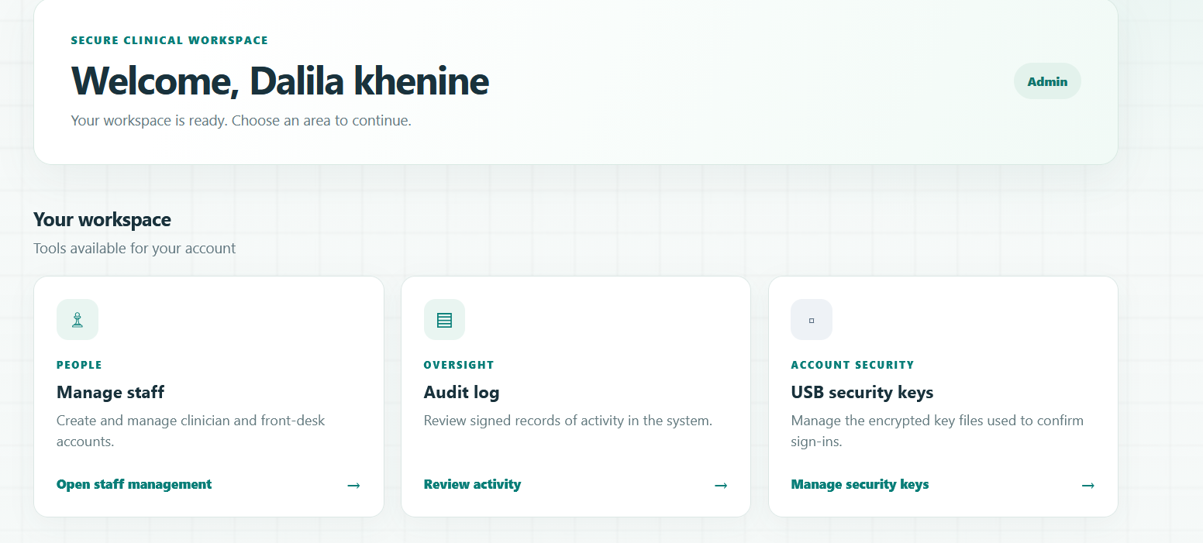
For the assignment lead doctor:
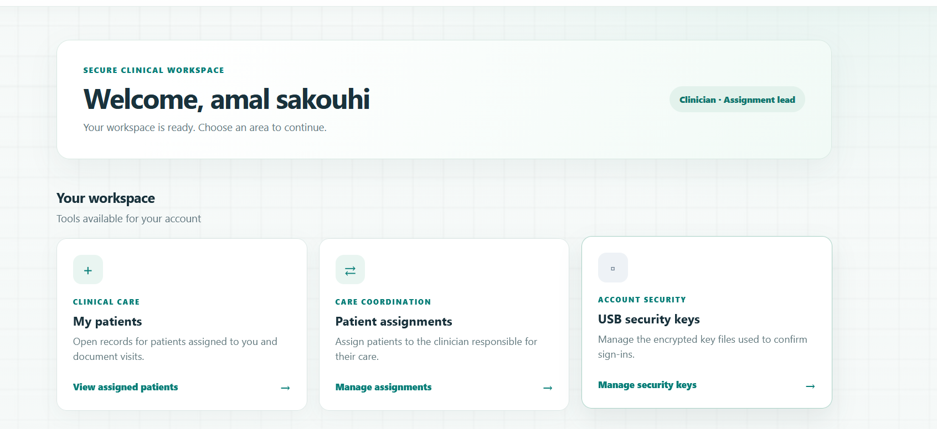
For the front desk:
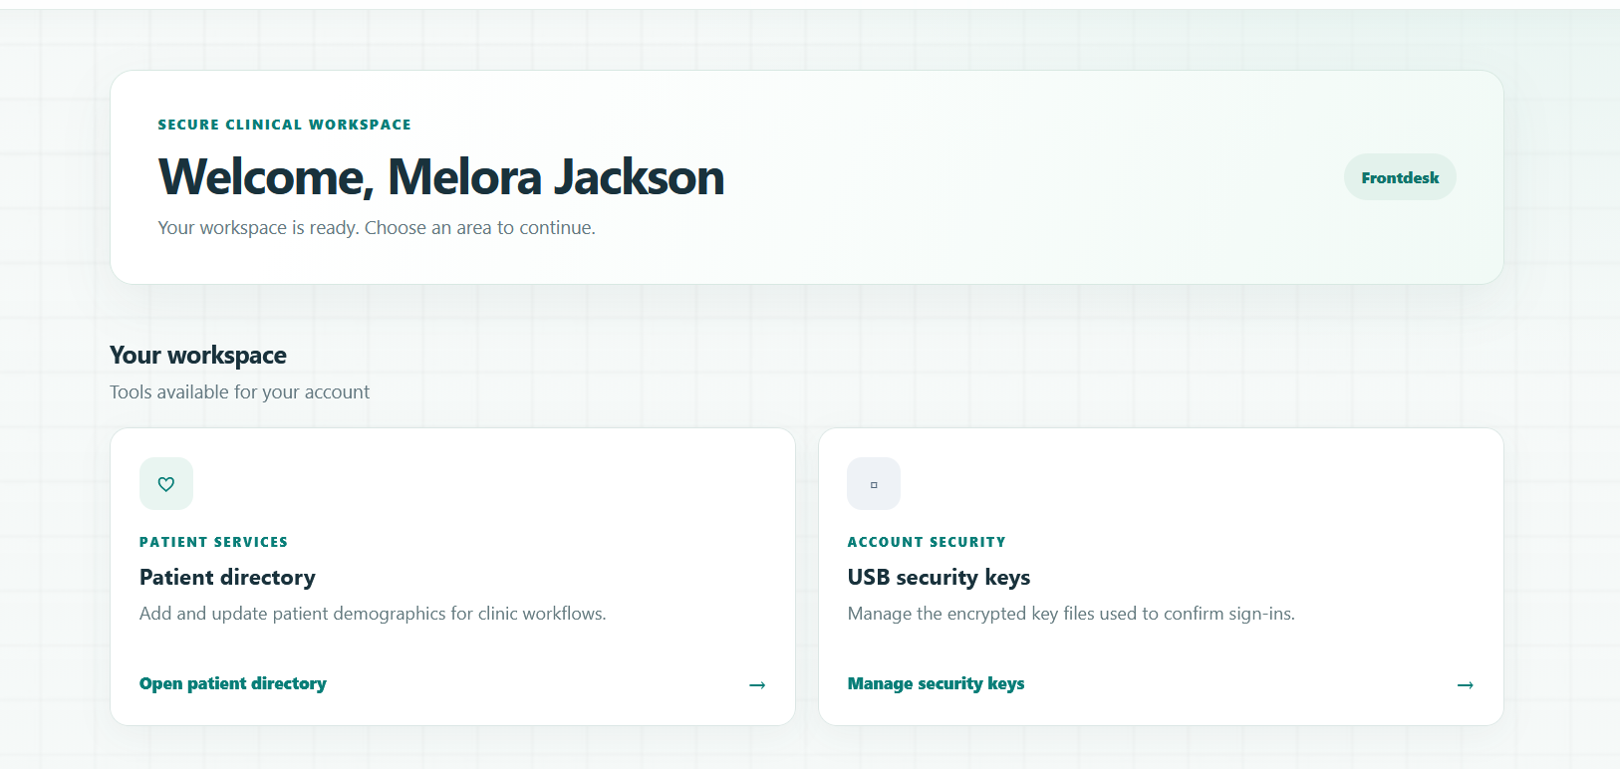
For the clinician:
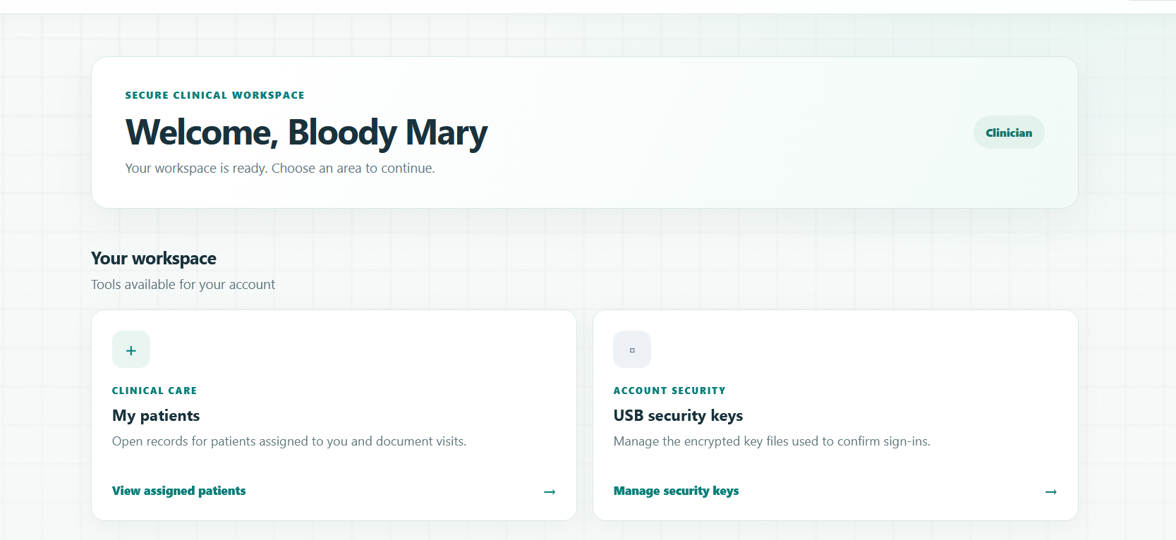

3. Authentication and USB key file
Passwords are hashed with bcrypt; the application does not store plaintext passwords. The password policy requires at least 10 characters, at least one number, and at least one special character. Five consecutive incorrect passwords for an existing account trigger a 15-minute temporary lockout. Login errors are generic so that the response does not disclose whether a username exists.
The second factor is designed for an ordinary USB flash drive. In the browser, the user creates an ECDSA P-256 key pair. The private key is encrypted in a downloadable key file with a separate passphrase and saved by the user to the USB drive. At login, the browser decrypts the private key locally and signs a fresh server challenge. The server checks the signature with the stored public key before creating a session. The private key is not sent to the server.
Scope clarification: the USB drive stores the encrypted key file; it is not itself a hardware cryptographic token. A copied key file still requires its separate passphrase.
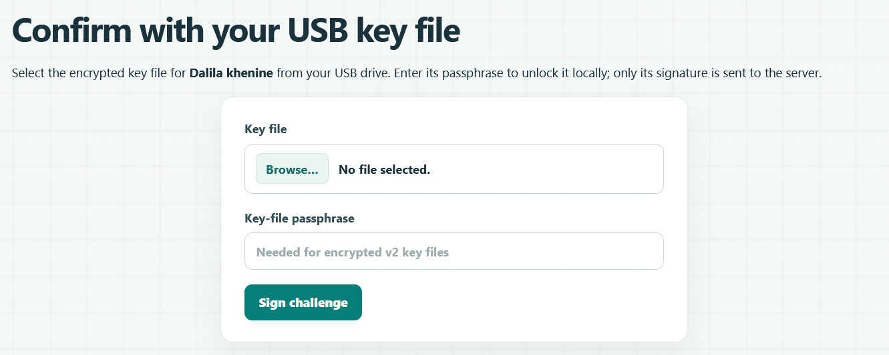

4. Patient data protection and auditability
Every clinician-facing patient and note operation checks whether the clinician is assigned to that patient. This check helps prevent direct URL changes from exposing another clinician’s records. Front-desk access is limited to demographic workflows and is blocked from clinical-note routes.
Clinical note text is encrypted before it is stored in SQLite using AES-256-GCM and a fresh nonce. The encryption key is provided through the MEDICAL_STRONGROOM_ENCRYPTION_KEY environment variable and is not stored in the database. Patient demographics are not encrypted by the application, so the database must contain synthetic data for this project demonstration.
Security-relevant events are written to an audit log. Each event is signed with HMAC-SHA-256 and linked to the previous event. The admin audit page checks the signatures and links, allowing it to flag modified records or deletion of a middle record. A local database alone cannot independently detect deletion of only the final events.
Browser security controls include CSRF validation for state-changing requests, a restrictive Content Security Policy, and additional response headers. Session cookies are configured for safer defaults; local HTTP demonstration requires the secure-cookie setting to be disabled for localhost, while deployment behind HTTPS should use secure cookies.
The doctor can create a note to their assigned patients without getting access to other patients:
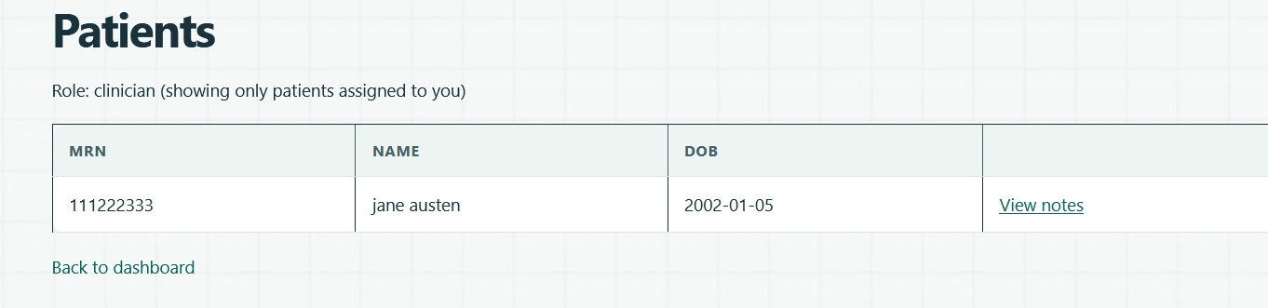
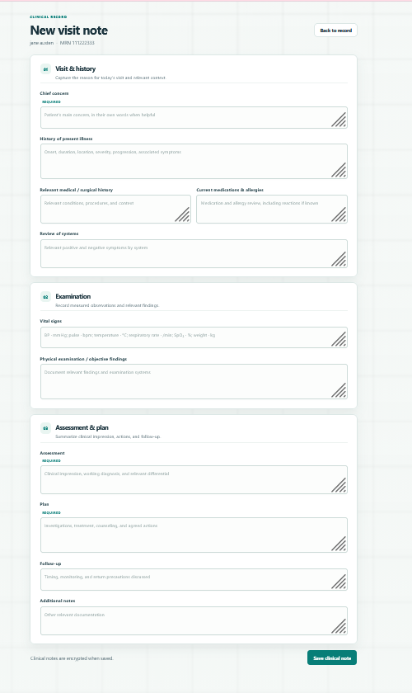

The front desk can only modify general info of the patients.

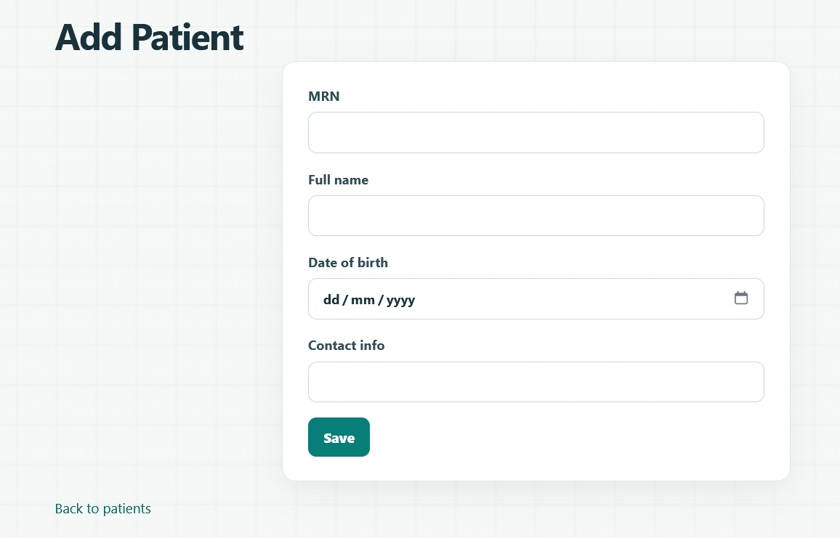
The administrator can only see the logs without seeing the patients notes.
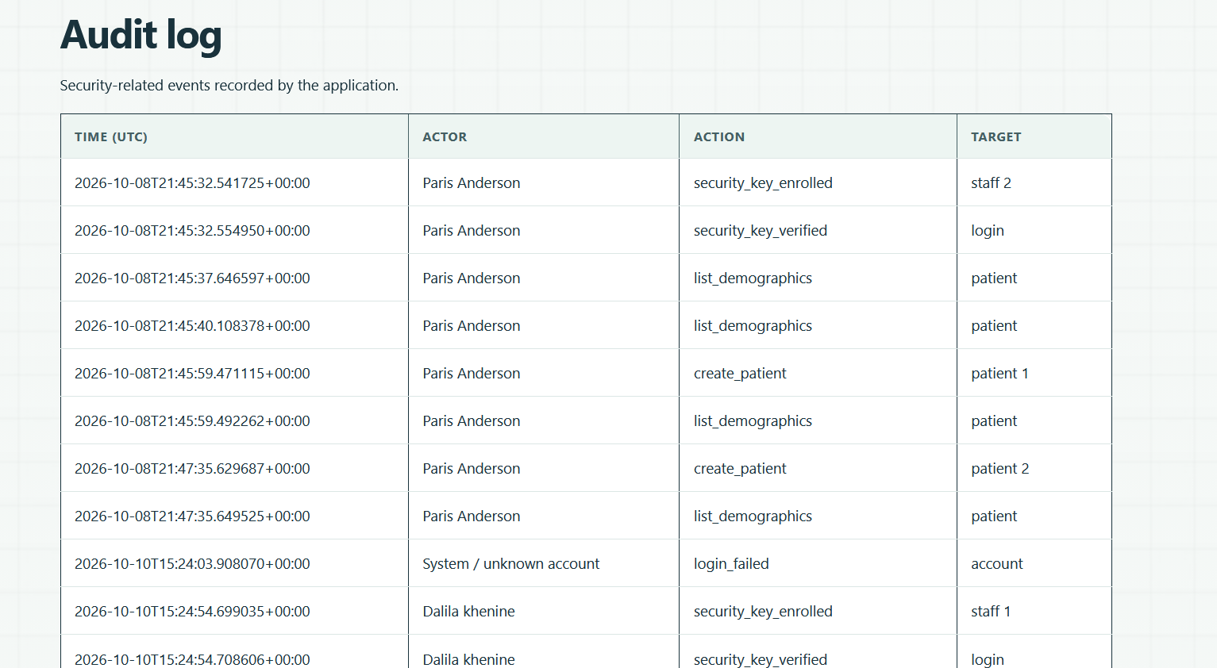

The assignment clinician can assign patients to the equivalent doctor without seeing any notes.
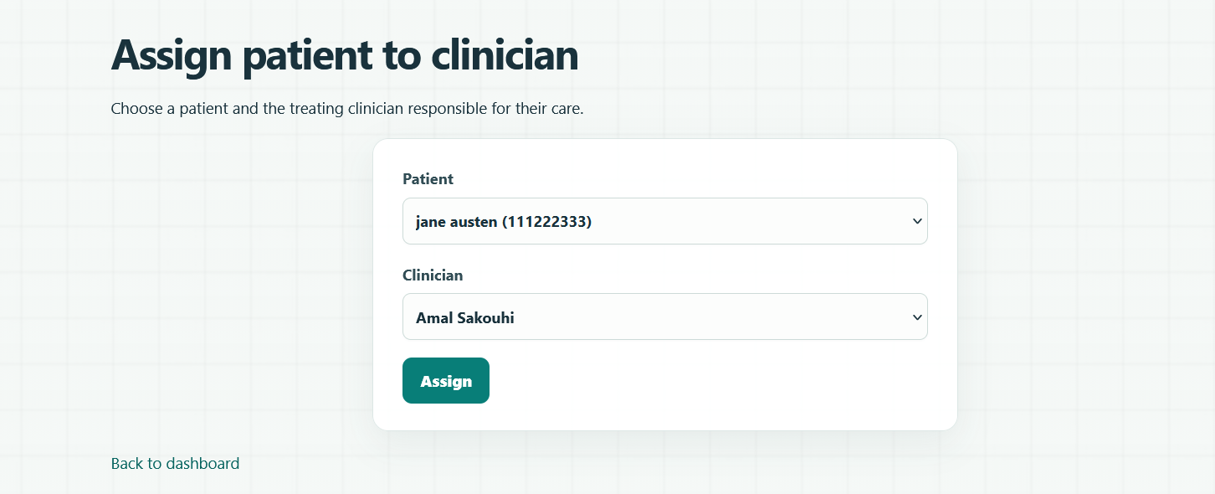

5. Test evidence
The project includes a unittest security suite using Flask’s test client and a temporary SQLite database populated with synthetic records. The README records a run on 10 October 2026 with 12 tests passing. This is focused regression evidence for application behavior; it is not a penetration test, a full security audit, or a production-readiness assessment.
Area checked | Examples of covered behavior
Authentication | bcrypt password verification, generic login errors, failed-login lockout, USB challenge signature, session expiry, and logout/deactivation.
Web protections | Protected routes, security response headers, and rejection of missing CSRF tokens or cross-origin requests.
Authorization | Role restrictions on clinical notes and denial of access to patients not assigned to a clinician.
Data integrity | AES-GCM ciphertext and nonce tampering, audit-record tampering, and deletion from the middle of the audit chain.
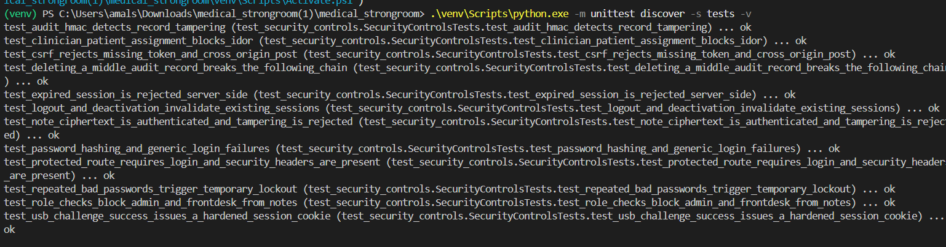
Other manual testing was done like:

Authentication
[ x] Try logging in with a wrong password and a nonexistent username. Confirm that the error message is generic.
[ x] Log in, log out, then try using the old session again. Confirm that protected pages are inaccessible. session hijacking testing
[x ] Trigger repeated failed logins and confirm that the temporary lockout is enforced.

Role-based access
[x ] Log in as an administrator and try opening a patient's notes directly by URL.
[ ] Log in as front-desk staff and try accessing the notes URL directly.
[x ] Log in as a clinician and try accessing an unassigned patient's notes by changing the patient ID in the URL.
[x ] Verify that each role can perform its permitted actions but cannot access restricted functions.

Privacy and auditing
[ x] Open a clinical note as an authorized clinician and inspect whether the access generates an audit event.
[ x] Check that an unauthorized attempt does not expose the note contents in the response.
[ x] Use synthetic notes only; verify that stored note data is ciphertext rather than readable plaintext.

Web behavior
[ x] Open protected pages in a fresh private browser window and confirm that login is required.
[x ] Inspect browser developer tools for the session cookie's HttpOnly, Secure (when HTTPS is used), and SameSite attributes.
[x ] Try submitting a protected form without a valid CSRF token and confirm that the request is rejected.

6. Local demonstration
The app is run locally from the project folder in a Python virtual environment. Before the first run, the operator installs the listed dependencies, creates and saves separate encryption and audit secrets, and runs the bootstrap scripts for the administrator, Paris Anderson, and the assignment lead. The Flask development server is then opened at http://127.0.0.1:5000. The README contains the exact PowerShell commands.
A concise demonstration can show a staff request waiting for approval, an administrator approving it, USB key-file enrollment, the assignment lead assigning a sample patient, the clinician viewing only assigned patients and adding a structured note, and the administrator reviewing the audit log. The lockout and automated tests can be summarized briefly rather than spending the video on repeated failed sign-ins.

7. Limitations and future work
Medical Strongroom is a classroom prototype, not a system for real patient data. It uses Flask’s development server and SQLite and does not provide a production WSGI deployment, managed secret storage, database-file encryption, or automated encryption-key rotation. Key loss has no complete self-service recovery path; the user needs a registered backup key or administrator-assisted password reset, and password reset does not replace a lost USB key. Security tests cover selected controls but do not establish that the application is secure against all attacks.
Before any real deployment, the project would need a production server behind HTTPS, strict host and proxy configuration, protected and tested backups, access-controlled secret storage, a reviewed key rotation and recovery process, independent security review, and operational policies for patient data. Until then, demonstrations should use synthetic patient information only.

Conclusion
Medical Strongroom demonstrates a practical security model for a small clinic workflow: staff roles define what actions are available, assignments define which patients clinicians can access, encrypted key files add a second sign-in factor, clinical notes are encrypted at rest, and linked audit signatures make some record tampering detectable. The test suite provides evidence that selected controls work as designed, while the stated limitations make clear that the application remains an educational prototype.

